SXTrader Manual

*Version 2.1*

www.sxtrader.net

8/7/2013

Version 2.1

Table of Contents

Table Of Figures 3

Foreword 5

Acknowledgement 5

Source of Download & Installation 6

Download 6

Installation 7

Updates 10

Starting SXTrader 12

Main User Interface 14

Titlebar 14

Menu 14

Module Tree 15

Module View 15

Message Window 15

Statusbar 15

Account Balance 15

Liveticker State 15

Common Configuration 15

Liveticker Interval 16

Sport Exchange Interval 16

Confirm Fast Bets 16

Debug Information 16

Logging 17

Log Liveticker 17

Log Trades 17

Log Bet Amounts 17

Statistics & Analyses 18

Match List 18

Default Color Schemes & Information Icons 19

Customer Defined Color Schemes 20

Manual Liveticker Connection 25

View Historic Data 27

View Match Details 28

View Extended Statistics 29

Score Matrix 30

Win/Loss/Draw 32

Over/Under 33

Liveticker Mapping 35

Lay The Draw 36

Konfiguration 37

Trade Configuration 37

Fast Bet Configuration 39

Sound Configuration 41

Fast Bet and Rule Based Bets 41

Fast Bet 42

Preplay Bet 42

Inplay Bet 43

Trade Overview 46

Tipster Integration 48

Layer Of Profit 48

Configuration 49

Trade View 55

The Low Lay 56

Configuration 57

Trade View 63

Trade The Reaction 65

# Table Of Figures

Figure 1: Link to the download page of SXTrader 6

Figure 2: Download link of the different SXTrader versions 7

Figure 3: Extractor for Installation Files 7

Figure 4: Setup Wizzard Page 1 8

Figure 5: Setup Wizzard Page 2 9

Figure 6: Setup Wizzard Page 3 10

Figure 7: Dialog with update informations 11

Figure 8: Starting Dialog with information 12

Figure 9: Sport Exchange Login Dialog 13

Figure 10: Main User Interface of SXTrader 14

Figure 11: Common Configuration Dialog SXTrader 16

Figure 12: A Complete view on the module Statistics & Analyses 18

Figure 13: Display of a match before start 18

Figure 14: Display of a running match 18

Figure 15: Display of an ended match 19

Figure 16: Match with no liveticker connection 19

Figure 17: Match with a single liveticker connection 19

Figure 18: Match with both liveticker connections 19

Figure 19: Running match 19

Figure 20: Ended match 19

Figure 21: Information icons red cards 20

Figure 22: Information icons Trades 20

Figure 23: Dialog Customer Defined Color Schemes – Without Rules 21

Figure 24: Dialog Customer defined color scheme – New rule – Color selection 22

Figure 25: Dialog customer defined color scheme – New rule – New statistic 23

Figure 26: Dialog customer defined color scheme – Example of a more complex rule 24

Figure 27: Match list with applied customer defined color schemes 25

Figure 28: Manual mapping dialog 26

Figure 29: Selected Match 27

Figure 30: Dialog for setting maximum amount and age of data 27

Figure 31: Historic Data View 28

Figure 32: View Match Details 29

Figure 33: View Extended Statistics 30

Figure 34: Definition of color schemes for Score Matrix 31

Figure 35: Score Matrix with applied color schemes 31

Figure 36: Definition of color schemes for Win/Loss/Draw 32

Figure 37: Win/Loss/Draw-Representation and Trends with applied color schemes. 33

Figure 38: Definition of color schemes for Over/Under 33

Figure 39: Over/Under-Representation and Trends with applied color schemes. 34

Figure 40: View Liveticker Mapping 35

Figure 41: Configuration Lay The Draw – Trading behaviour 37

Figure 42: Configuration Lay The Draw – Fast Lay 40

Figure 43: Configuration Lay The Draw – Sound 41

Figure 44: Fast Bet and Rule Based Bets Lay The Draw – Entry Screen 42

Figure 45: Preplay Bet Lay The Draw – Definition Dialog 43

Figure 46. Inplay Starter Lay The Draw – Definition Dialog 44

Figure 47: Trade Overview Lay The Draw 46

Figure 48: Configuration Layer Of Profit – Common Settings 49

Figure 49: Configuration Layer Of Profit – Mail Settings 50

Figure 50: Configuration Layer Of Profit – Trade Behaviour Settings 52

Figure 51: Configuration Layer Of Profit – Bankroll Management 54

Figure 52: Trade View Layer Of Profit 55

Figure 53: Configuration The Low Lay – Common Settings 57

Figure 54: Configuration The Low Lay – Mail Settings 58

Figure 55: Configuration The Low Lay – Trade Behaviour Settings 60

Figure 56: Configuration The Low Lay – Bankroll Management 62

Figure 57: Trade View The Low Lay 63

# Foreword

SXTrader is a bot for automated trading on soccer markets at sport exchanges.

The current version 2.0 of SXTrader supports the sport exchanges [Betfair](http://ads.betfair.com/redirect.aspx?pid=69255&bid=3797) and [Betdaq](http://affiliate.cdn.betdaqaffiliates.com/redirect.aspx?pid=3045&bid=1850).

SXTrader is Freeware. This means the user does not have to pay for the usage of SXTrader in any form. But the programmer of SXTrader is asking for support because he is paying for the website and the database servers with his own money.

There are two ways to support the developer: The first one is to hit the donation button at the startup of SXTrader. The second one is to sign up at websites via the banners on [www.sxtrader.net](http://www.sxtrader.net) .

# Acknowledgement

I want to special thank the user “Kites”. He wrote the original manual for SXTrader. Without him there wouldn’t be a manual today because I, like most developers have an aversion to documenting my work.

I also want to specially thank theSXTrader user BG33. He has done the proofreading for the english Version of this manual.

# Source of Download & Installation

## Download

SXTrader can be downloaded at <http://www.sxtrader.net>.

At the web page of SXTrader you have to click the Item “Download SXTrader” on the left side. This will redirect you to the download page.

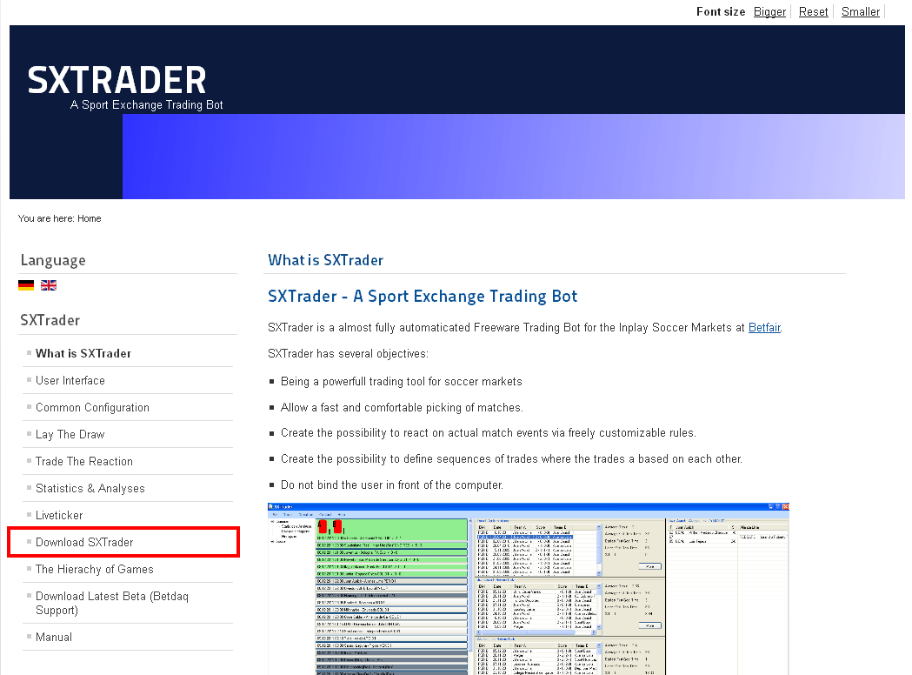

Figure 1: Link to the download page of SXTrader

At the Download Page you can either download the standard version of SXTrader or a special version for Windows 64-bit systems.

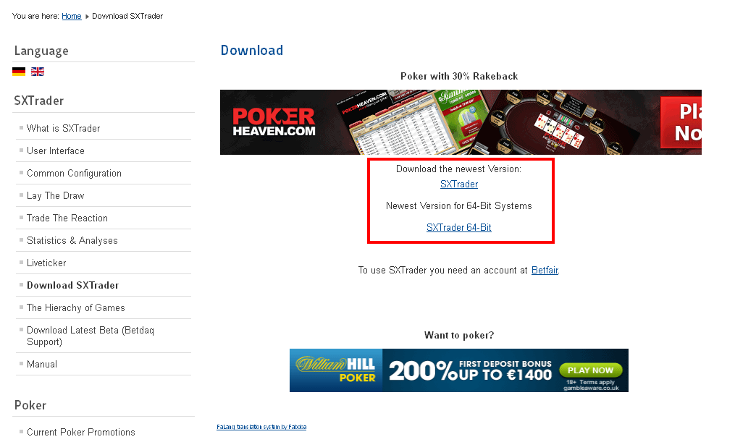

Figure 2: Download link of the different SXTrader versions

## Installation

After the download there should be a file called SXTrader.exe or SXTrader64.exe in your download folder.

Now this file has to be executed. To execute just double click on the file name. This starts the extraction program for the installation files. At the extraction programe you can define where to extract the files.

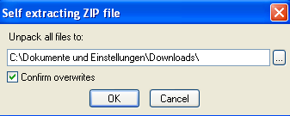

Figure 3: Extractor for Installation Files

After the extractor has finished the file “setup.exe” in the directory where the files have been extracted has to be executed. This will start the installer of SXTrader.

You can confirm the first dialog window of the setup wizzard by pressing the button “Next”.

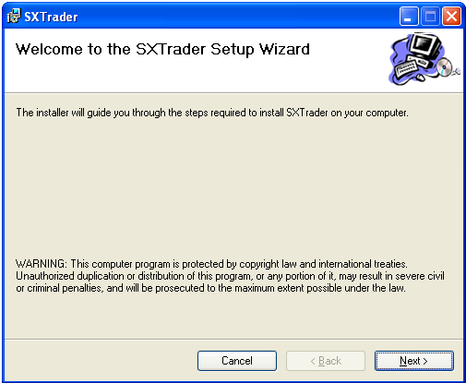

Figure 4: Setup Wizzard Page 1

At the second dialog the destination directory for this installation can be changed. Usually the suggested value is accepted by pressing the button “Next”.

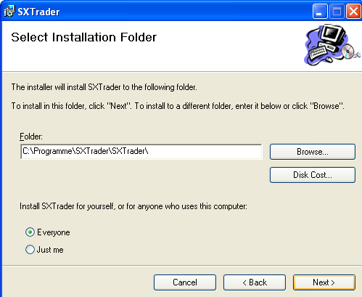

Figure 5: Setup Wizzard Page 2

The third dialog is just for confirming. If the button “Next” is pressed then SXTrader will be installed at the given directory.

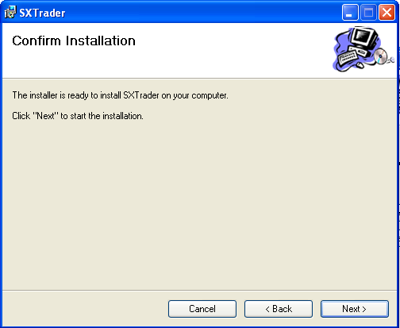

Figure 6: Setup Wizzard Page 3

After the installation there should be a start menu entry and a desktop icon called SXTrader.

## Updates

At startup SXTrader checks if there is a new version available. If this is the case a dialog with update informations will be displayed.

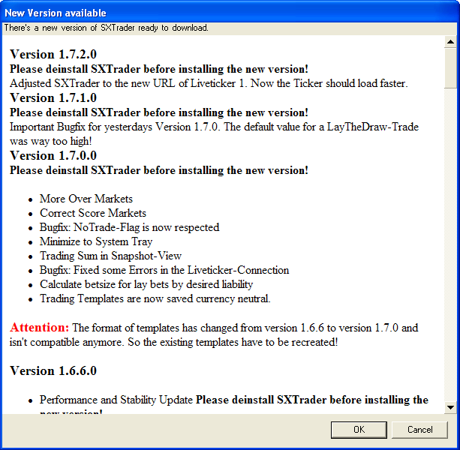

Figure 7: Dialog with update informations

SXtrader will only be runable with the latest version!

By clicking the button “OK” a webbrowser is opened with the download page. When clicking the Button “Cancel” the update will be declined and SXTrader will shut down.

SXTrader Version 1 will be runable independently from version 2 but there will not be any new updates as it has reached its end of life.

Before installing a new version please deinstall the old one first!

# Starting SXTrader

SXTrader is started by selecting the appropiate start menu entry or by double click on icon of SXTrader at the desktop.

If no new update is available (see Updates) an information dialog is shown. In this dialog you have the opportunity to make a donation to SXTrader. There will also be a window with interesting news and advertising.

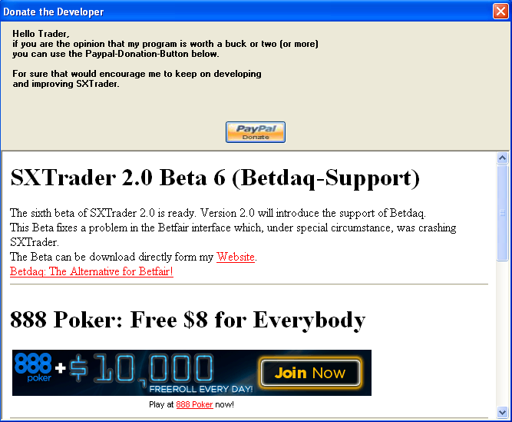

Figure 8: Starting Dialog with information

You can close this dialog by pressing the red X in the top right corner.

Now the sport exchange login dialog is displayed.

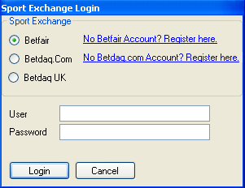

Figure 9: Sport Exchange Login Dialog

First the sport exchange where to log in has to be chosen. The selection is Betfair, Betdaq.com and Betdaq.co.uk. If you don’t have an account at the choosen sport exchange but want to open one you can click the link right of the sport exchange name. Now the web browser with the registration page of the sport exchange will be opened.

Betdaq.com and Betdaq.co.uk are two different entities with own user and passwords. You can have accounts on both.

After choosing the sport exchange you have to input your username and password into the input fields. After clicking the button “Login” your login data will be sent to the sport exchange. If an error occurs a message with the description of the error will be displayed. Otherwise the main user interface of SXTrader is loaded.

By pressing “Cancel” the login process is aborted and SXTrader is closed.

SXTrader will not save any passwords and is transferring the login data exclusively to the sports exchange only.

SXTrader will also not collect any kind of data which could identify a user and transfer it to the SXTrader Server or any other third party.

# Main User Interface

After a successful login the main user interface of SXTrader will be loaded.

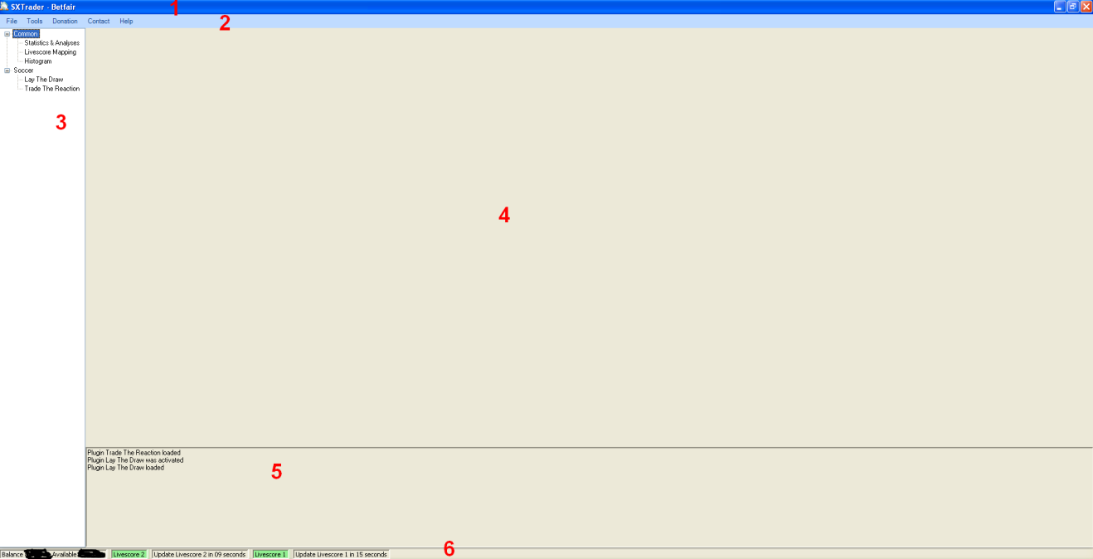

Figure 10: Main User Interface of SXTrader

The User Interface has several segments:

1. Titlebar
2. Menu
3. Module Tree
4. Module View
5. Message Window
6. Statusbar

## Titlebar

At the titlebar the name “SXTrader” + <Name of logged in sport exchange> is displayed.

## Menu

* File
  + Exit: Closes SXTrader
* Tools
  + Configuration: Opens the configuration dialog of SXTrader
* Donation: Opens a webbrowser window with the paypal donation page
* Contact
  + Report Bug: Opens the mail client with the email address for reporting a bug
  + Make a Suggestion: Opens the mail client with the email address for making a suggestion regarding SXTrader
* Help: Opens a webbrowser with [www.sxtrader.net](http://www.sxtrader.net)

## Module Tree

Here all available Moduls of SXTrader will be displayed.

## Module View

If a modul is selected at the Modul Tree its User Interface will be shown here.

## Message Window

At the message window all relevant news about trades and bets will be displayed

## Statusbar

The statusbar is informing the user about his account balance and the state of the liveticker connections.

### Account Balance

The first left element of the statusbar is the account balance. It is updated every minute. It contains following elements:

* Balance: The overall balance of the account
* Available: The amount of money available for bets.

### Liveticker State

There is an item for every connected liveticker which displays the state of it and a countdown until the next actualisation of the ticker data.If the name of the ticker has a green background then all is up and well. If the background is red then there was an error during the last update.

# Common Configuration

Common Configuration are the settings of SXTrader which are not exclusivly for a module but have effects on the whole application.

The Common Configuration can be found via this menu path: Tools🡪Options🡪Configuration🡪General

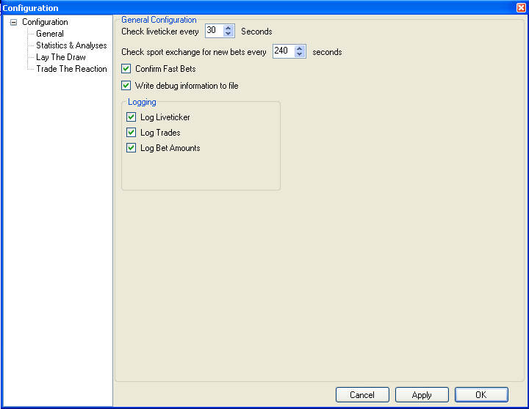

Figure 11: Common Configuration Dialog SXTrader

## Liveticker Interval

The value “Check liveticker every <x> Seconds” defines the time that has to pass before checking the liveticker for new information (e.g. Goals, Red Cards, Match Begin; Match End).

## Sport Exchange Interval

The value “Check sport exchange for new bets every <x> seconds> defines the time that has to pass before checking the sport exchange for new unknown or updated bets. This feature is only a fall back solution. Usually a Trade in SXTrader controls and watch its own bets itself.

## Confirm Fast Bets

If this checkbox is set then a confirmation question is displayed in a message box before placing a Fast Bet with SXTrader.

## Debug Information

If this checkbox is set then a file named DebugOutput.txt will be created in the base directory of SXTrader.

# Logging

The logging feature, unlike the debug information, is creating a file for each match. The files will be created in the directory \logs\<logginmodule> of the base directory. The name of the logging file will always have the following format: <Team A>_<Team B>.xml. The logging files will be stored for two days. Afterwards SXTrader will delete older files automatically.

Usually it is not neccessary to have the Debug Information and the Liveticker Logs activated.

But if you suspect an error you should activate them.

The Default settings of SXTrader after Installation will have the logging deactivated.

### Log Liveticker

If this checkbox is set then a file will be created for each match which has a connection between liveticker and sport exchange. The storage place for this file is \logs\liveticker. Within the file all signals of the liveticker regarding the match will be stored.

### Log Trades

If this checkbox is set then a file will be created for each match where a bet or a trade rule exists. The file will be stored under \logs\trades. Within the file all information about the decision processes of a trade will be stored.

### Log Bet Amounts

To protect the privacy of its User SXTrader does not store information about the bet amounts by default.

If this checkbox is set the information of the bet amounts will be stored in the Trade Logs.

# Statistics & Analyses

The Module Statistics & Analyses is the C&C-Center of the trading on Soccer Markets with SXTrader.

At the Module Tree you can find it at Common🡪Statistics & Analyses.

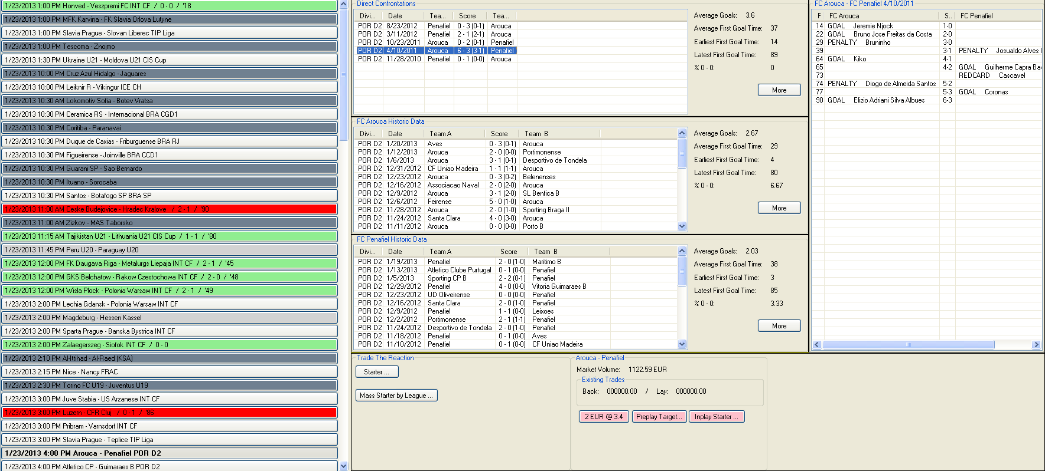

Figure 12: A Complete view on the module Statistics & Analyses

The Module Statistics & Analyses contains several segments. On the left side there is the match list with the inplay matches for the next 24 hours. In the middle there are the historic data lists. On the right side there is the detail view for match events of a historic match. On the Button there is the Fast Bet- and Ruleset area of the different trading modules of SXTrader.

## Match List

The match list is displaying the inplay matches of the next 24 hours. To give the user a better overview there are several different color schemes and information icons.

An unstarted match is displays the following information: Date and time the match begins – Name of the teams – League or Tourney.



Figure 13: Display of a match before start

If the match has started the information is changing to the following: Date and time the match begins – Name of Teams – League or Tourney – Score – Playtime.



Figure 14: Display of a running match

If the match has ended the information changes to following: Date and time the match begins – Name of Teams –League or Tourney – Final Score.



Figure 15: Display of an ended match

### Default Color Schemes & Information Icons

SXTrader contains some default color schemes and information icons to allow the user a quick overview of the state of a match.

If a match has no liveticker conection then the match will be displayed with a dark grey background.



Figure 16: Match with no liveticker connection

If a match has just a single liveticker connection then the background will be middle grey.



Figure 17: Match with a single liveticker connection

If a match is connected with both liveticker then the background will be light grey.



Figure 18: Match with both liveticker connections

If a match is running then the background will be green.



Figure 19: Running match

If a match has ended then the background will be red.



Figure 20: Ended match

A coloring if a match is running or has ended is only possible if at least one liveticker is connected

If a red card will be given to a team in a match and the information about it will be passed by the livetickers SXTrader will display an according information icon for the match. An “A” on the Icon means that this is the red card count for the home team. “B” on the icon means that this is the red card count for the away team.

If both teams have red cards then two icons will be displayed.



Figure 21: Information icons red cards

If at least one trading module is active on the match then an according icon will be displayed. The meaning of the icons will be explained in the chapters of said modules.



Figure 22: Information icons Trades

### Customer Defined Color Schemes

To give the user the opportunity to identify matches of interest quickly, especially on days with a high number of inplay matches, identify matches of interest SXTrader offers the feature to color a match in an individual color if a statistical ruleset is matched.

The dialog for customer defined color schemes can be called in the following way: Tools🡪Options🡪Configuration🡪Statistics & Analyses🡪Game Coloring.

By default there are no customer defined color schemes after the installation of SXTrader.

By pressing the button “New” a new Rule will be created.

The usage of colors which are already used by SXTrader for other purposes should be avoided.

Otherwise the match list could be misleading.

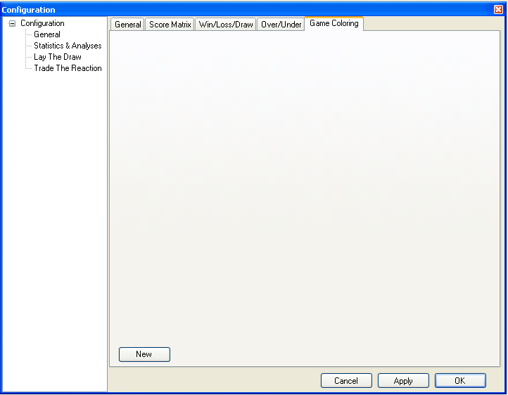

Figure 23: Dialog Customer Defined Color Schemes – Without Rules

Now a new rule definition is shown in the dialog. In the next step a color is selected in which a match at the match list is colored if the rule applies.

It is recommended to add to every rule a check for number of data.

This ensures that the color selection is meaningful.

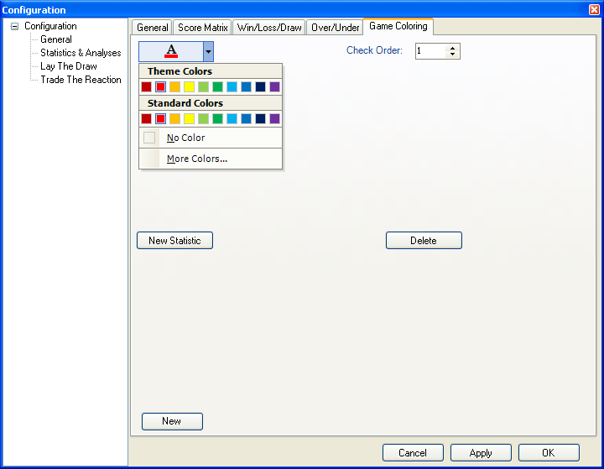

Figure 24: Dialog Customer defined color scheme – New rule – Color selection

After selecting a color a new check value is created by pressing the button “New Statistic”.

Now a statistic is created which has to apply if a match should be displayed with the selected color. To do so several different values have to be selected.

1. Team selection
   1. Both Teams: Only use data from direct confrontations.
   2. Team A: Only use data from the home team.
   3. Team B: Only use data from the away team.
2. Home / Away Selection
   1. Home and Away: Use data from both home and away matches. In case of “Both Teams” this is always from the viewpoint of the home team of the current match.
   2. Home: Use data from home matches only. In case of “Both Teams” this is always from the viewpoint of the home team of the current match.
   3. Away: Use data from away matches only. In case of “Both Teams” this is always from the viewpoint of the home team of the current match.
3. Statistic: The statistic the selection should be applied on.

After the kind of data and the statistics to use is defined the value range to apply has to be defined.

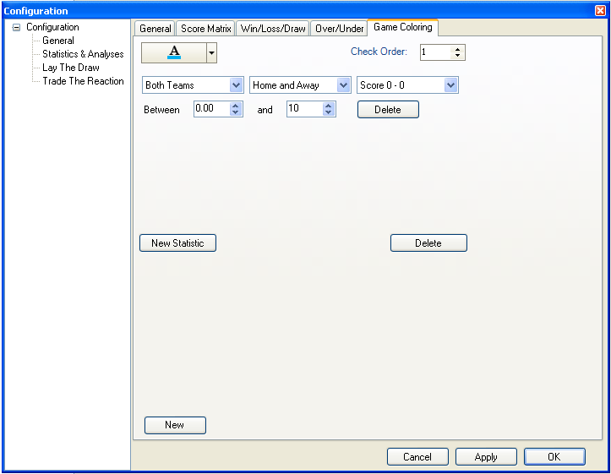

Figure 25: Dialog customer defined color scheme – New rule – New statistic

If several customer color schemes have been defined then there also has to be a check order. SXTrader is repeating through the customer color schemes rules in that defined check order until it has passed through all the rules or have found a match.

With pressing the button “Apply” or “OK” a rule is stored.

A newly defined customer color scheme first applies after SXTrader is restarted.

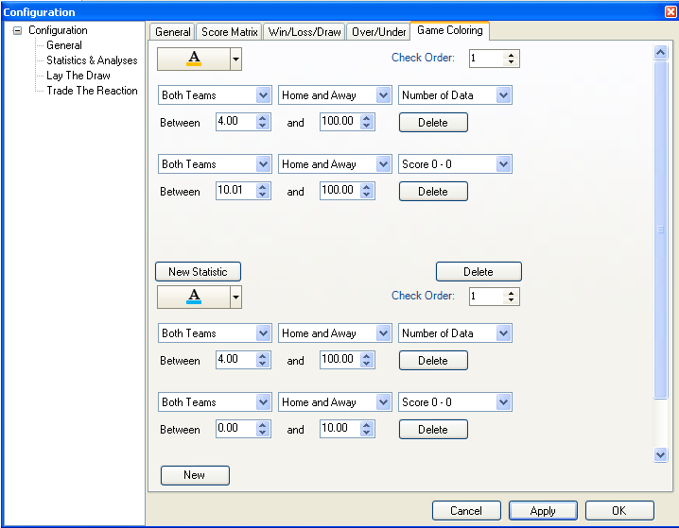

Figure 26: Dialog customer defined color scheme – Example of a more complex rule

Customer defined color schemes will only be applied on matches that have not started and with Liveticker 1 connection.

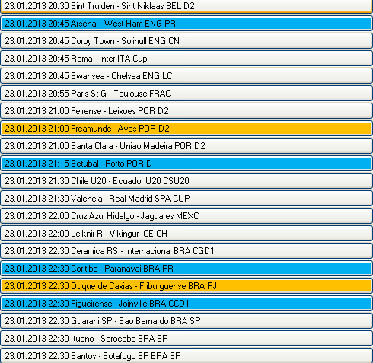

Figure 27: Match list with applied customer defined color schemes

### Manual Liveticker Connection

The names of a teams on a sport exchange and on a liveticker can differ. Therefore SXTrader has its own mapping table of the names. At every start of SXTrader it will be checked if a new version of that table is available and if necessary updated. Anyway sometimes it happens that a match or a team could not be found in the mapping table. To fix this the user has the possibility to create a local mapping.

To create such a mapping you have to click on the match in the match list with missing liveticker connection.

Now the manual mapping dialog opens.

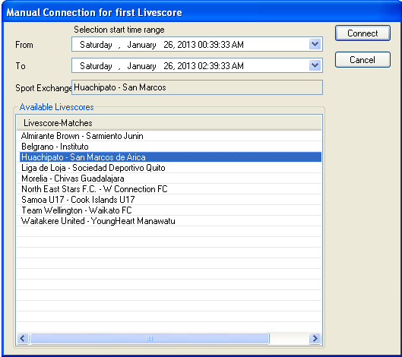

Figure 28: Manual mapping dialog

The title bar of the dialog tells which liveticker should be connected.

With the start time selection you can reduce the list of liveticker connection to those whose start time is within the selected interval.

SXTrader is storing manual mappings in a local file for later reuse.

At the text field Sport Exchange the name of the match as it is used at the sport exchange is displayed.

At Available Livescores all matches at the livetickers that are within the selected start time interval are displayed.

If a fitting match has been found the mapping can be confirmed by pressing the button “Connect”.

by pressing “Cancel” the Mapping Dialog is closed and the manual mapping aborted.

## View Historic Data

If a match is selected at the match list (and liveticker 1 is connected) then the historic data of both teams will be loaded. Additionally the match will be marked with bold letters in the match list.



Figure 29: Selected Match

The amount and age of the data to load can be defined at the configuration.

The configuration dialog can be called this way:

Menu🡪Tools🡪Options🡪Configuration🡪Statistics & Analyses🡪General.

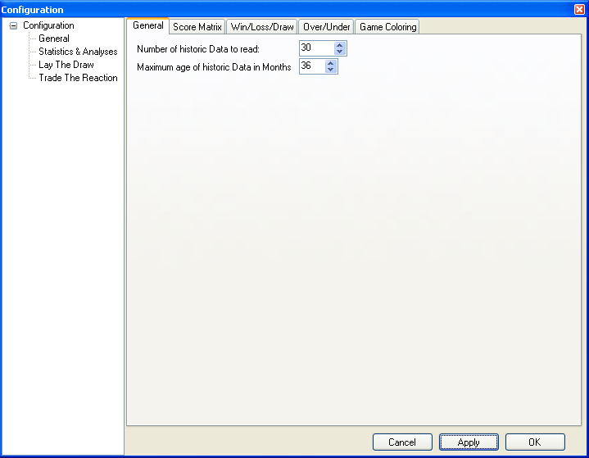

Figure 30: Dialog for setting maximum amount and age of data

The loaded data, if there are any, will be displayed at the historic data view.

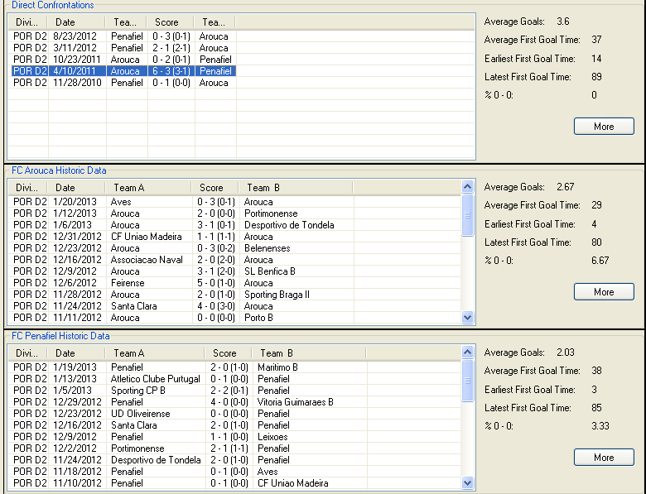

Figure 31: Historic Data View

The view has tree segments. The top segment shows the stored direct confrontation matches. The middle segment shows the stored matches of the home team. The bottom segment the stored matches of the away team.

Right beside the stored match lists some basic statistics are shown

By pressing the button “More” the Extended Statistics View is loaded.

If a match in the list of stored matches is selected the match detail view will be loaded.

## View Match Details

The match details lists what happened during a match. Match details contain goals, penalties, owngoals, yellew, red, red-yellow-cards and the name of the respective players.

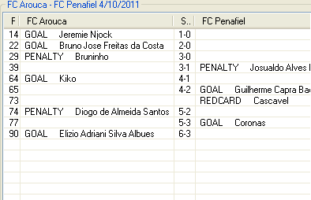

The quality of the match details can greatly vary. Usually at the major leagues all details are given but at minor or exotic leagues and older stored matches ( > 2007) some details might be missing.

Figure 32: View Match Details

## View Extended Statistics

If the button “More” is pressed at the view Historic Data then the Extended Statistics will be loaded. It does not matter on which segment of the View Historic Data you press the button because the view Extended Statistics always loads the data for direct confrontation, home team and away team.

The view Extended Data presents several statistics in a more graphical way. Here the datablocks could again be preselected by home/away, home, away matches. The label “n=<number>” shows how many datasets where used for the calculation of the statistics.

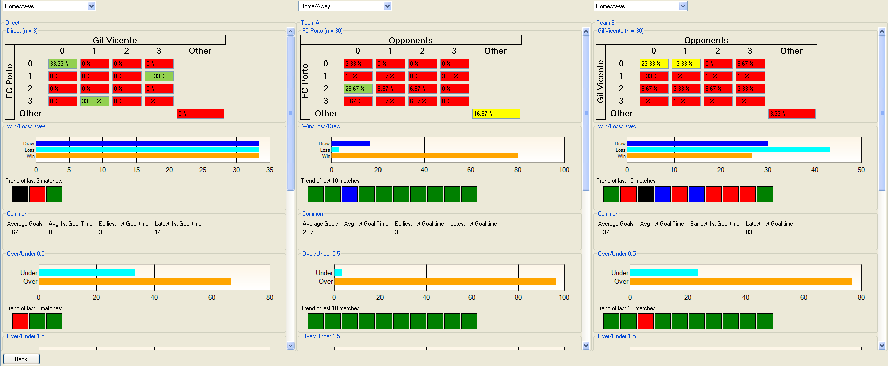

Figure 33: View Extended Statistics

### Score Matrix

Purpose of the Score Matrix is to give a graphical presentation of the distribution of the results on the loaded datasets.

Wich color scheme should be used for which percentage range is freely customizable by the user.

The definition dialog for the color schemes of the score matrix can be called this way:

Menu🡪Tools🡪Options🡪Configuration🡪Statistics & Analyses🡪Score Matrix

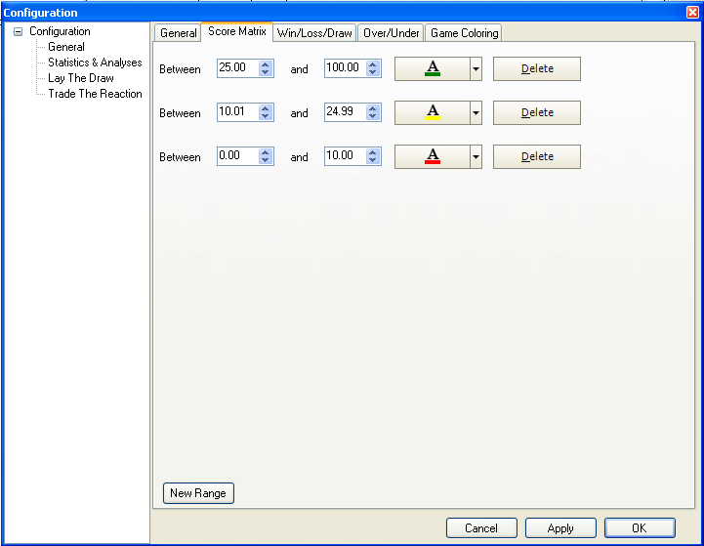

Figure 34: Definition of color schemes for Score Matrix

A new color scheme is created by pressing the button “New Range”. A color scheme always needs a value range for which the chosen color should be valid. With pressing “Apply” or “OK” the color scheme will be saved.

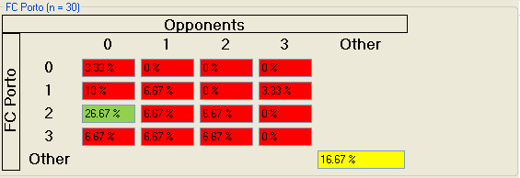

Figure 35: Score Matrix with applied color schemes

### Win/Loss/Draw

The Win/Loss/Draw-Display as well as the trend-display over the maximal last 10 is used to give a reprensentation of the match results and the trend in the results in a graphical way.

Which value range color scheme should be used is customizable by the user. The same goes for the colors of the trends

The definition dialog for the color schemes of the Win/Loss/Draw can be called this way:

Menu🡪Tools🡪Options🡪Configuration🡪Statistics & Analyses🡪Win/Loss/Draw

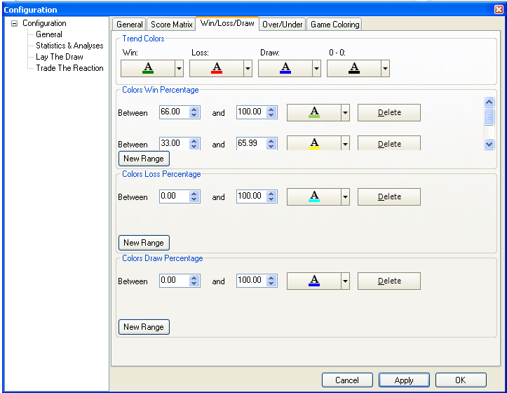

Figure 36: Definition of color schemes for Win/Loss/Draw

At the top segment of the dialog you can define the colors for the results which will be used for the trend display. The possible results used for a trend are: Win, Loss, Draw and Final Score 0 – 0. This is used as a separate value for the trend display because for most ways of trading on soccer markets a Final Score of 0 – 0 is the worst case situation.

The following segments show the color scheme definition for the bar diagram. This is a representation of results.. The definition of the values works in the same way as described at Score Matrix.

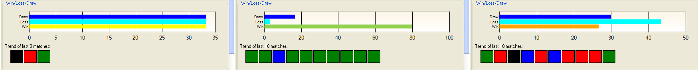

Figure 37: Win/Loss/Draw-Representation and Trends with applied color schemes.

### Over/Under

The Over/Under-Display, as well as the trend-display over the maximum last 10, is used to give a representation of the goal total and the trend in the goal total in a graphical way.

The color scheme value range to be used is customizable by the user. The same goes for the colors of the trends

The definition dialog for the color schemes of the Over/Under can be called this way:

Menu🡪Tools🡪Options🡪Configuration🡪Statistics & Analyses🡪Over/Under

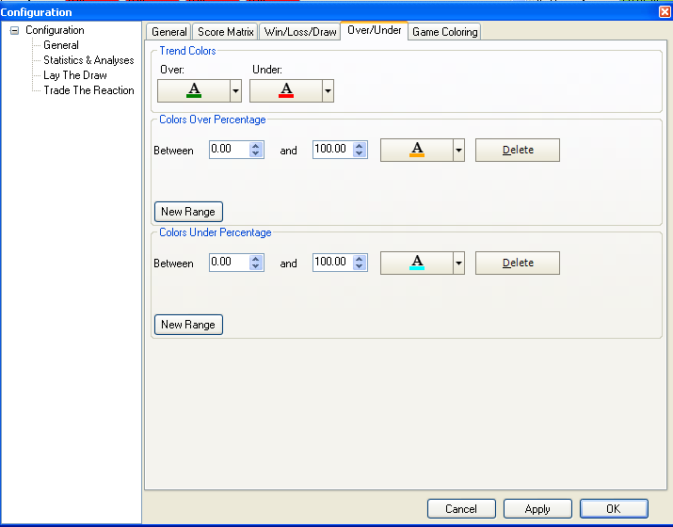

Figure 38: Definition of color schemes for Over/Under

The procedure to define color schemes is the same as described in Win/Loss/Draw.

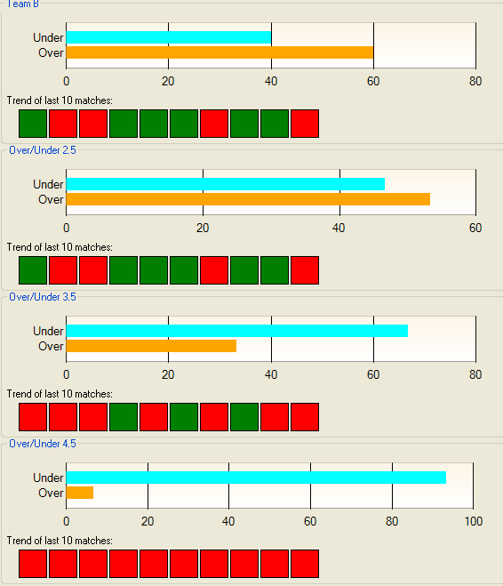

Figure 39: Over/Under-Representation and Trends with applied color schemes.

# Liveticker Mapping

It may happen that an error was made when doing a Manual Liveticker Connection. This will result in the wrong mapping pair being written to the local file. And this again could lead to one severe problem: The wrong liveticker map will be connected to the sport exchange map. As a result a potential trade will use the wrong signals from the liveticker and is makin an incorect decision based on those signals.

To fix such an incorrect mapping pair the user can delete it in the View Liveticker Mapping.

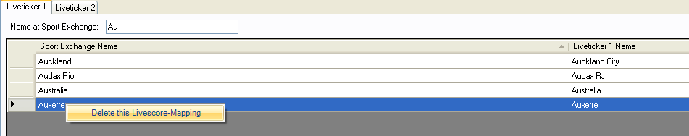

Figure 40: View Liveticker Mapping

The View has a tab for each Liveticker. Each tab again has the same layout. On the top there is an input field called “Name at Sport Exchange”. Here you can filter the local mapping data by inputing characters. This will reduce the displayed mapping by team names which begin with the inputed sequence.

If you detect an errorneous entry you can delete it by right clicking on it and choosing “Delete this Livescore Mapping”.

# Lay The Draw

Lay The Draw is one of the most popular and most widespread trading strategies used on sport exchanges. It is based on the fact that normally the odds for the draw rise after a goal is scored.

A final score of 0 -- 0 is the worst case scenario for a Lay The Draw Trade as the odds are likely to continue falling during the match. There won’t be a opportunity to trade out with a win.

SXTrader offers an opportunity to use a Stopp/Loss in such a case.

You can take advantage of this by placing a lay bet as long as the score is a draw or before the match starts. After a goal is scored you can place a back bet. This combination usually results in a win whatever the outcome of the match acutally will be.

SXTrader is supporting this strategy with its own module called Lay The Draw.

## Konfiguration

### Trade Configuration

The configuration of the trading behaviour can be found via following path:

Menu🡪Tools🡪Options🡪Configuration🡪Lay The Draw🡪Game Behaviour.

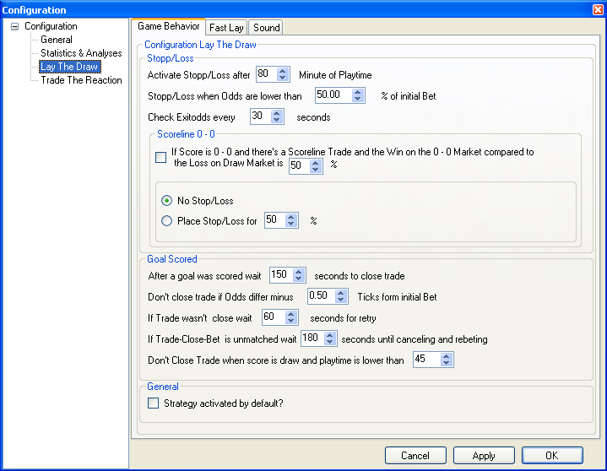

Figure 41: Configuration Lay The Draw – Trading behaviour

The trading behaviour configuration contains 3 parts:

* General: Independent trading behaviour
* Stop/Loss: Definition of the Stopp/Loss-Trigger and behaviour
* Goal Scored: Definition of the trade out behaviour after a goal is scored.

#### General

The segment “General” conains only one configuration element. If “Strategy activated by default” is checked then the Lay The Draw-Module is active when SXTrader is started and can, if necessary, trade matches.

This value is deactivated after the installation of SXTrader by default.

#### Stop/Loss

Stop/Loss defines the behaviour for a trade out in case a win on this trade becomes unlikely. It places a counter bet to minimize the loss.

* Activate Stop/Loss after <x> Minutes of Play: The match play time when SXTrader checks if the Stop/Loss criteria have been fullfilled.
* Stop/Loss when odds are lower then <x> % of initial bet: Calculates the odds when a Stop/Loss is placed relative to the lay odds of the initial bets.
  + **Example:** The value is set to 50% and there are two lay bets on the draw market. The lay bets were placed for the odds of 3.7 and 4.0. This results in an average odd of 3.85. If the back odds after the Stop/Loss check has been activated fall below the odd of 1.93 then a back bet will be placed to equalize and minimize the loss outcome independently.
* Check exit odds every <x> seconds: After the Stop/Loss-Check has been activated use the given value as the interval for checking whether the exit odds has been hit.
* If the Score is 0 – 0 and there is a scoreline trade: If this is checked it will be evaluated if this game should trade on the Correct Score Market 0 – 0 (a so called Scoreline 0 -- 0 Trade) and if the winnings on that trade is higher than the given percentage of the potential loss on the Draw Market.
  + No Stop/Loss: Don’t place a Stop/Loss Bet
  + Place Stop/Loss for <x> %: Place a counter bet as a Stop/Loss which will cover given percentage of the loss on the Draw Market.

If the value of „Activate Stop/Loss after <x> Minute of play time will be set to -1 then no Stop/Loss Observation will be started.

#### Goal Scored

This segment defines the behaviour of SXTrader after a goal is scored and a trade out bet should be placed.

* After a goal is scored wait <x> seconds to close trade: This value defines the amount of seconds which have to pass by after the notification of a goal was received before further checks for an possible trade out will be made.
* Don’t close the trade if odds differ minus <x> ticks from initial bet: Defines a minimum odds relative to the initial odds which has to be reached before a trade out bet will be placed.
  + **Example 1:** The value is set to 0.5.The average odds of the lay bet is 4.0. Now, after a goal is scored, the odds for the back market has to reach at least 3.5 before a trade out is made.

**Attention:** „Don’t close the trade if odds differ minus“ is utilising an inverse logic!

* + **Example 2:** The value is set to -0.5. The average odds for the lay bet is 4.0. Now, after a goal was scored, the odds for the back market has to reach at least 4.5 before a trade out is made
* .If trade wasn’t closed wait <x> seconds for retry: If the trade out bet could not be placed on the draw market, e.g. the market is still suspended, then wait the given amount of time before retrying.
* If Trade close bet is unmatched wait <x> seconds until cancelling and bet again: If a trade out bet is unmatched or partly matched SXTrader will wait for the given time before checking the bet again. If it is still unmatched or partly matched the bet will be cancelled and a new bet will be placed.
* Don’t close trade if score is draw and playtime below <x>: If a second goal is scored which equilizes the score and playing time is below the given value then don’t place trade out bet.

If the value of "After a goal wait <x> seconds then trade out" is set to -1 no trade out will be made.

### Fast Bet Configuration

The base configuration of the bet amount for fast bets and rule based bets can be called the following way:

Menu🡪Tools🡪Options🡪Configuration🡪Lay The Draw🡪Fast Lay.

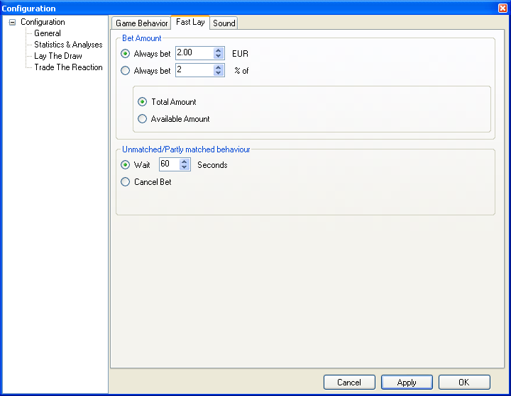

Figure 42: Configuration Lay The Draw – Fast Lay

#### Bet Amount

This configuration values define the standard height for the bet amount for fast bet and rule based bets.

**„Alway bet <x> <currency> means the bet amount and not the risk at lay bets.**

* Always bet <x> <Currency>: Always use the given fixed value.
* Always bet <x> % of: Always calculate the bet amount in the percantage relative to
  + Total Amount: The total bankroll
  + Available Amount: The available bankroll

#### Unmatched/Partly matched behaviour

This defines how SXTrader will act if a lay bet is unmatched or partly matched during a fast bet or a rule based bet.

* Wait <x> seconds: Wait given time then check state of the bet again. If it is still unmatched or partly matched then wait again.
* Cancel Bet: Cancel the unmatched or partly matched bet.

### Sound Configuration

The Lay The Draw Module is offering the opportunity to play sounds if certain events happen.

The Configuration can be found at:

Menu🡪Tools🡪Options🡪Configuration🡪Lay The Draw🡪Sound.

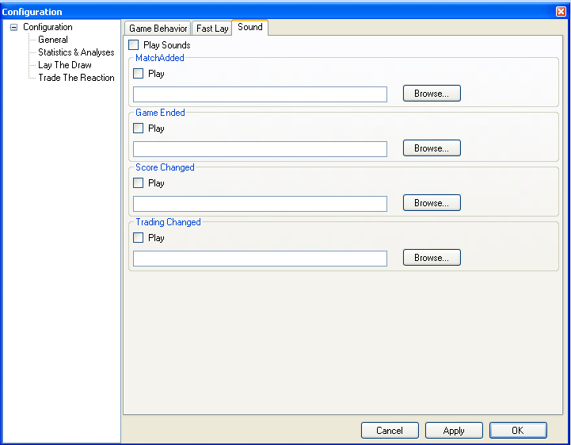

Figure 43: Configuration Lay The Draw – Sound

## Fast Bet and Rule Based Bets

The entry for the Fast Bet and Rule Based Bets can be found at Statistics & Analyses. There the Lay The Draw Module is attaching its Interface for Fast Bet and Rule Based Bets.

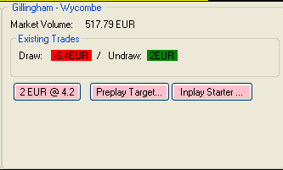

Figure 44: Fast Bet and Rule Based Bets Lay The Draw – Entry Screen

The first half of the screen gives some common information. On the top there is the name of the match. Followed by the market volume of the draw market. Then there is the information if there is already a Lay The Draw Trade for this match and what its state is.

**The Market Volume in SXTrader displays the amount of the matched bets and not the total amount of matched and unmatched bets.**

In the second half there are the actual functions for Fast Bet and Rule Based Bets. These are:

* Fast Bet
* Preplay Bet
* Inplay Bet (aka Rule Based Bet)

### Fast Bet

By pressing the button for Fast Bet a lay bet for the displayed value is placed at the draw market immediately. The bet amount is defined at Fast Bet Configuration. If the value Confirm Fast Bets is selected a confirm dialog appears. Otherwise the bet will be placed without any further questions.

### Preplay Bet

By pressing the button “Preplay Target” the dialog for setting up a preplay bet is shown.

This dialog has two segments. In the first the definition for the bet amounts are shown. They have the same meaning as described at Bet Amount.

At the segment, this is where the difference to the Fast Bet is, the value for the desired odd for the lay bet is inputted. How SXTrader will react if the desired amount could not be matched is defined at Unmatched/Partly matched behaviour.

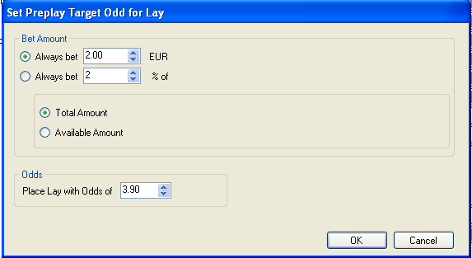

Figure 45: Preplay Bet Lay The Draw – Definition Dialog

### Inplay Bet

By pressing “Inplay Starter” the definition dialog for the rule based inplay bet is loaded. This dialog contains three segments:

* List of existing Rules
* Definition Area
* Common Dialog Functions

#### List of Existing Rules

The list of existing rules displays those rules which are active for this match.

By pressing “Edit” the rule will be loaded into the Definition Area.

By pressing “Delete” the rule will be deleted.

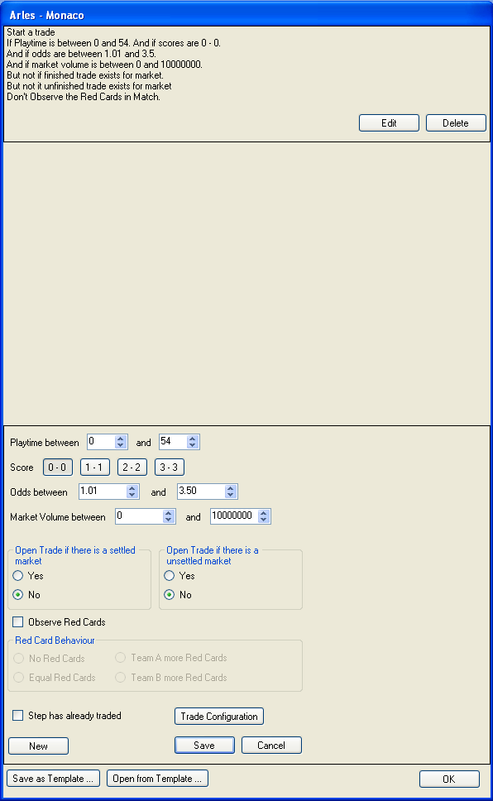

Figure 46. Inplay Starter Lay The Draw – Definition Dialog

#### Definition Area

At the Definition Area the triggers which have to been fullfilled before SXTrader starts a fully automated trade (aka is placing a lay bet) for the selected market.

* Playtime between <x> and <y>: Defines the range of the playtime in which this rule should be valid.
* Score Defines the scores for which this rule should be valid.
* Odds between <x> and <y>: Defines the range in which the odds must be so that the rule is valid.

**Betfair and Betdaq calculate the market volume diffently!**

* Market Volume between <x> and <y>: The range of the Market Volume for which this rule should be valid.
* Open Trade if there is a settled market: Allows to place a new Lay Bet even if the former trade on this market is already settled. Settled means that a back bet has been placed and now the result for this trade is independent from the acutal outcome of the match.
* Open Trade if there is an unsettled market: Allows to place a new Lay Bet even if there is already a trade for this match and no back bet to settle this market has been placed yet.
* Observer Red Cards: Takes the situation of the red cards of the match into consideration before deciding if a rule has been fullfilled or not.
  + No Red Cards: Neither team is allowed to have red cards
  + Equal Red Cards: Both teams have to have the same number of Red Cards
  + Team A more Red Cards: The home team has to have more Red Cards than the Away Team.
  + Team B more Red Cards: The Away Team has to have more Red Cards than the Home Team
* Step has already traded: If SXTrader has executed this rule once successfully it will set this flag to prevent the step from being executed again. The User can remove this flag. If this is done it may happen that this rule is executed again.
* Trade Configuration: Loads a dialog similar to Default Konfiguration Dialog of the Lay The Draw Module. There the betting amount and trading behaviour can be set individually for this match and this rule.
* Button “New”: Creates a new rule
* Button “Save”: Saves the current rule and attaches it to the List of Existing Rules.
* Button “Cancel”: Aborts the editing of the current rule without saving it.

#### Common Dialog Functions

At the Area of the Common Dialog Functions you can find the buttons which will influence the whole rule set.

* Button “Save as Template”: Stores the current rule set in a file at the hard disk for later usage.
* Button “Open from Template”: Opens a file with a stored ruleset , assigns it to the current match and closes the Inplay Bet Dialog.
* Button “OK”: Assigns the rule set to the chosen match and closes the Inplay Bet Dialog.

## Trade Overview

Each recognized Lay The Draw Trade will be displayed as a row at the Trade Overview.

The Trade Overview of Lay The Draw can be found at the Module Tree at Soccer🡪Lay The Draw.

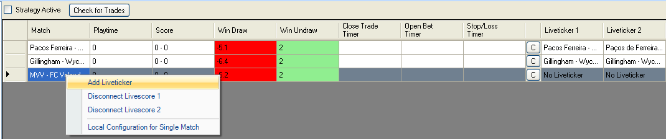

Figure 47: Trade Overview Lay The Draw

At the top of the Trade Overview there are two common functions of the Lay The Draw Module:

* Strategy active: If this is unchecked SXTrader stops trading Lay The Draw Trades. It will still display the Trades but will not take any action on the markets.
* Check for Trades: If a bet on the draw market is placed outside of SXTrader then it will usually be recognized directly after the time definied at Sport Exchange Interval has been passed. But to speed up the process the user can press this button. Then the sport exchange will be checked immediately for bets.

Following the common functions the list of the running matches with Lay The Draw Trades is shown. Each Trade has its own line. A row contains several columns which have the following meaning:

* Match: Name of the match as it is known at the sport exchange.
* Playtime: Actual playtime of the match.
* Score: Actual score of the match
* Win Draw: Profit or Loss if the match has ended with a draw.
* Win Undraw: Profit or Loss if the match has ended without a draw
* Close Trade Timer: Countdown which starts after a goal is scored until the trade is checked if there is a trade out.
* Open Bet Timer: If a bet at a trade out was unmatched this countdown indicates how long until the bet is checked again.
* Stop/Loss Timer: If a Stop/Loss might be necessary this countdown indicates how long until the requirements for a Stop/Loss are checked.
* C: Displays the Local Configuration for this match.
* Liveticker 1: Name of the match as it is known at Liveticker 1.
* Liveticker 2: Name of the match as it is known at Liveticker 2.

If the user right clicks on a trade then a context menu with the following options is displayed:

* Add Liveticker: If a liveticker connection is missing this option loads the Manual Liveticker Connection Dialog.
* Disconnect Liveticker 1: Disconnects the Liveticker 1 from this match. This may become necessary if there was an error while doing a Manual Liveticker Connection.
* Disconnect Liveticker 2: The same as above just for Liveticker 2.
* Local Configuration for Single Match: This displays the dialog for the local trading configuration.

# Tipster Integration

Tipsters are Services, which provide betting tips to their customers. With the rise of the internet and the spreading of online bookmakers and sport exchanges the tipster services boomed.

If you enlist to a profitable tipster, even if he costs money monthly, it could be a nice boost to your bankroll.

Unfortunaly there is a little problem with it: You need time to translate the tips into bets and most tipster send their tip mails in the morning where the most of us are working and don’t have time. This could be because you are working at the line in some factory or your company firewall is blocking the access to bookmakers sites or you could be in a conference with customers.

And even if you can spare a few minutes to hastly place the bets for the tips, e.g. through a smart phone, this my cause more harm than good. What if the tip event will be in a few hours and the odds are not perfect no? What if the bet remains unmatched? What if the odds are shifting into your favor?

**SXTrader recommends to open an email account for each tippster service subscribed!**

This is where the tipster integration of SXTrader jumps in. Its aim is to fully automating the proces of receiving the tip mails and translate it into bets according to the configuration.

With Version 2.1 of SXtrader there will be the integration of two horse tipster: [Layer Of Profit](http://f6daec9ju3i10u43he1dqnvt4g.hop.clickbank.net/?tid=MANUAL) and [The Low Lay](http://31ab6h-h-xo83le7rju1cpooal.hop.clickbank.net/?tid=MANUAL)

## Layer Of Profit

[Layer of Profit](http://f6daec9ju3i10u43he1dqnvt4g.hop.clickbank.net/?tid=MANUAL) is a tipster servcie which send one lay tip a day via email to its customers. It defines a maximum lay odd of 4.0. If the lay odd is above that maximal [Layer Of Profit](http://f6daec9ju3i10u43he1dqnvt4g.hop.clickbank.net/?tid=MANUAL) recommends to place a unmatched lay bet for that odd anyway and keep it InPlay/InRunning.

SXTrade, if you are subscriber of [Layer Of Profit](http://f6daec9ju3i10u43he1dqnvt4g.hop.clickbank.net/?tid=MANUAL), reads the tip email and bets according to its configuration. With this automatismn it is often possible to get better odds for the lay bet and so minimize the loosings in case of a lost bet.

At the web site of SXTrader there is an [Performance Log](http://www.sxtrader.net/layer-of-profit) for that service which will be updated at least two times a month.

### Configuration

#### Common Settings

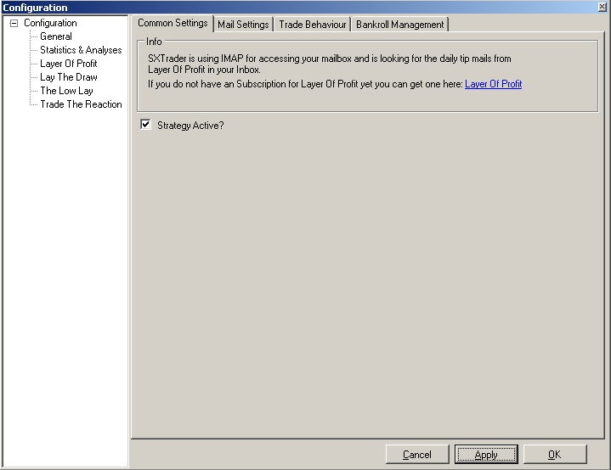

Figure 48: Configuration Layer Of Profit – Common Settings

At the tab “Common Settings” of the Module Layer Of Profit at SXTrader you have the possibility to activate or deactivate the module.

**The Module Layer Of Profit is deactivated by default after installation.**

**If you change the value “Strategy Active” you have to restart SXTrader**

#### Mail Settings

As SXTrader needs to read the tip emails it is necessary that it has access to the email account where the tip mails are send to.

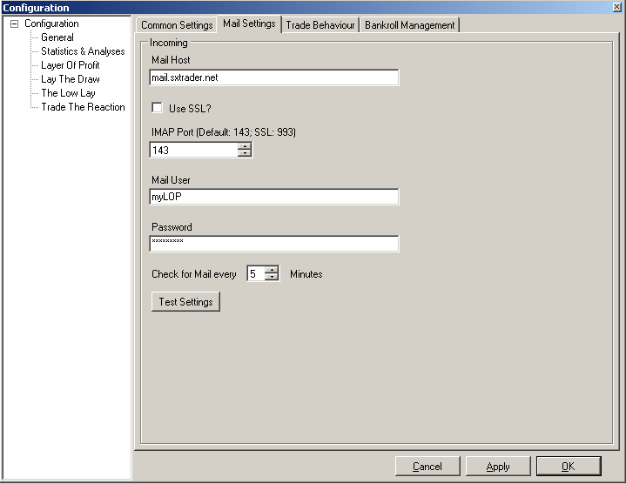

Figure 49: Configuration Layer Of Profit – Mail Settings

##### Mail Host

This is the URL where the IMAP-Server of the mail provide is accessable.

##### Use SSL

If the access to the mail provide is done with SSL (Secure Socket Layer) this flag must be checked.

**SXTrader is saving your account and access data encrypted.**

##### IMAP Port

The port via with the requests are send to the Mail Host. For unsecure access it is port 143 by default and for secure access via SSL it is 993 by default.

##### Mail User

The username used to log into the mail account.

##### Password

The password used to access the mail account.

##### Check for Mail every <x> Minutes

This defines the interval for SXTrader to look into the mail account for new tip mails. The range of the interval can be between 5 (Default) and 1440 Minutes.

##### Test Settings

**Testing of the settings may take several minutes of time depending on your mail provider**

By pressing this button a connection test with the current mail settings will be done.

#### Trade Behaviour

With the Trade Behaviour Settings you can control when, how and if an incoming tip mail will be processed into a bet.

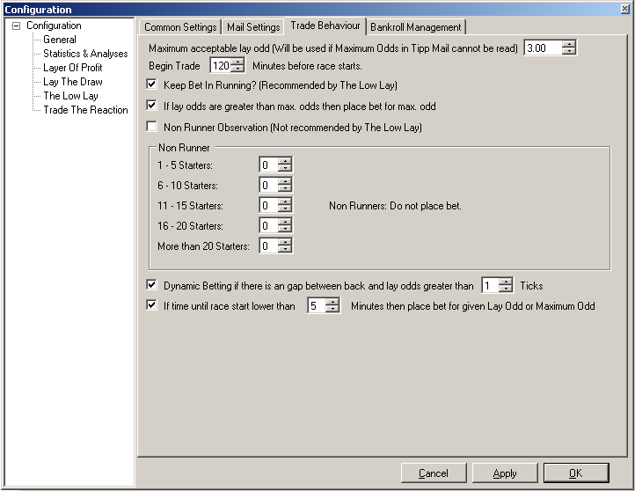

Figure 50: Configuration Layer Of Profit – Trade Behaviour Settings

##### Maximum acceptable Lay Odd

This value defines the maximum Odd to which an lay bet would be placed.

##### Begin Trade <x> Minutes before the race starts

The value defines the point of time when SXTrader should begin to try to place a bet for the tip according to the defined rules.

**Example:** The Value for begin trade is set to 60 Minutes. The daily tip of Layer Of Profit is telling you to lay the horse Stresa at the race Kempton at 8:30 PM. This means the earliest point in time when SXTrader is trying to place a lay bet will be 7:30 PM.

##### Keep Bet In Running

If this flag is activated the bets will be placed with the option Keep InRunning/InPlay which will cause that the bet if it isn’t matched won’t be canceled when the race starts.

##### If Lay Odds greater than max. odds

If this flag is activated SXTrader will place a lay bet for the maximum odd if the best odds for laying is greater than the defined maximum odd.

**Example:** The best lay odd for a tipp is 4.5 at the moment but the maximum allowed odd would be 4.0. So SXTrader wouldn’t be allowed to place a lay bet for the best lay odd. Instead SXTrader is placing a bet with the odd of 4.0. Most likely this bet remains unmatched but we hope that the odds are shifting in our favor and we would be on the top of the list if the bet gets matched.

##### Non Runner Observation

If this flag is activated SXTrader will count the number of non starter at a race and deceide depending on the original start field size whether it is allowed to place a bet.

###### 1 – 5 Starter

Maximum allowed number of non starter if the starter field size is between 1 and 5 horses.

###### 6 – 10 Starter

Maximum allowed number of non starter if the starter field size is between 6 and 10 horses.

###### 11 – 15 Starter

Maximum allowed number of non starter if the starter field size is between 11 and 15 horses.

###### 16 – 20 Starter

Maximum allowed number of non starter if the starter field size is between 16 and 20 horses.

###### More than 20 Starter

Maximum allowed number of non starter if the starter field size has more than 20 horses.

##### Dynamic Betting

If this flag is activated SXTrader will not just look at the lay site of the odds but also at the back site. If it detectects a gap between the best odd at the lay side and the best odd at the back side which is greater than the defined value it will adjust its trading behaviour accordenly. The same when SXTrader detects that we have the highest odd on the back side with our unmatched bet, we are the sole bettor for that odd and there’s a gap between our odd and the seconde best back odd.

**Example 1:** The odds situation of a horse to tip is following: The best odd at the lay side is 4.5 and the best odd at the beack side is 3.3. Now SXTrader will place a lay bet for the odd of 3.35 (3.3 + 1 Tick). The bet remains unmatched. SXTrader will check the unmatched bet minutely. When checking SXTrader detects there is now a higher odd of 3.4 on the back side in front of us. Now SXTrader will cancel the bet of 3.35 and place a new on for the odd of 3.45 (3.4 + 1 Tick). SXTrade will continue this until the bet is matched or the maximum odd is reached.

**Example 2:** The odds situation of a horse to tip is following: On the back side the best odd is 3.9 and we are sole provider of that odd. The second best odd is 3.5. Now SXTrader will cancel our bet and place a new one for the odd of 3.55 (3.5 + 1 Tick).

##### If Time until Race Starts is lower than <x> Minutes

If this flag is activated and the time until race start is lower than the given amount of minutes SXTrader will stop any kind of dynamic trading, cancel all open bets and place a new lay bet for the best available lay odd or if this odd is higher than the maximum odd a lay bet for the maximum odd.

#### Bankroll Management

At the Bankroll management you are configuring the betting amount for the tips to place

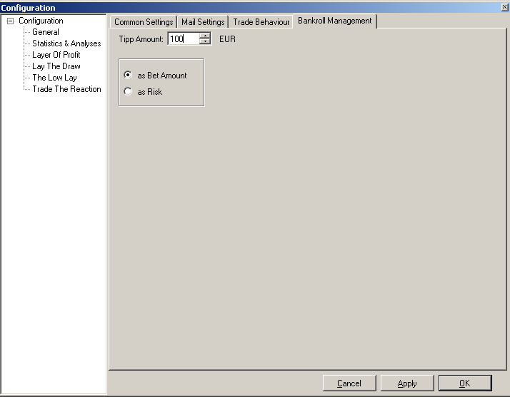

Figure 51: Configuration Layer Of Profit – Bankroll Management

##### Tip Amount

The amount of money to use for the bets. The value will always be in your account currency. By default SXTrader will use the minimum stake of the logged in sport exchange after installation (Betfair 2€; Betdaq 0.50€).

##### As Bet Amount

The Value of Tip Amount should be used as stake of the lay bet.

##### As Risk

The value of Tip Amount should be the maximum risk of the lay bet.

### Trade View

If a tip is detected by SXTrader its state will be displayed at the Trade View of the Module Layer Of Profit.

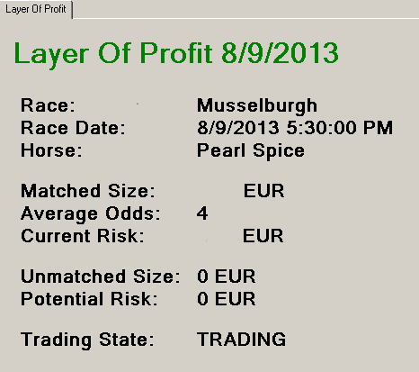

Figure 52: Trade View Layer Of Profit

* Race: The Race of the tip
* Race Date: The Start Time of the Race

**ATTENTION: The Race Date will always be displayed in your local time zone and not in UK-Timezone (unless you are in the UK)**

* Horse: Name of the Horse to lay
* Matched Size: The amount of money currently matched by bets. It will always be displayed in your account currency.
* Average Odds: The average Odd of all matched bets
* Current Risk: The money you are risking to loose if the lay bet is lost. It will always be displayed in your account currency.
* Unmatched Size: The amount of money placed in currently unmatched bets. It will always be displayed in your account currency.
* Potential Risk: The amount of money you are going to risk if the currently unmatched bets will be matched and you are loosing the lay bet. It will always be displayed in your account currency.
* Trading State: The state of the trade. Possible values are: STARTED;TRADING;COMPLETED;NONRUNNER und NOTTRADING

## The Low Lay

[The Low Lay](http://31ab6h-h-xo83le7rju1cpooal.hop.clickbank.net/?tid=MANUAL) is a tipster service which send one lay tip a ay via email to its customers. Such an email contains the race, the start date, the name of the horse and a maximum odd for the lay.

SXTrader, if you are subscriber of [The Low Lay](http://31ab6h-h-xo83le7rju1cpooal.hop.clickbank.net/?tid=MANUAL), reads the tip email and bets according to its configuration. With this automatismn it is often possible to get better odds for the lay bet and so minimize the loosings in case of a lost bet.

At the web site of SXTrader there is an [Performance Log](http://www.sxtrader.net/layer-of-profit) for that service which will be updated at least two times a month.

### Configuration

#### Common Settings

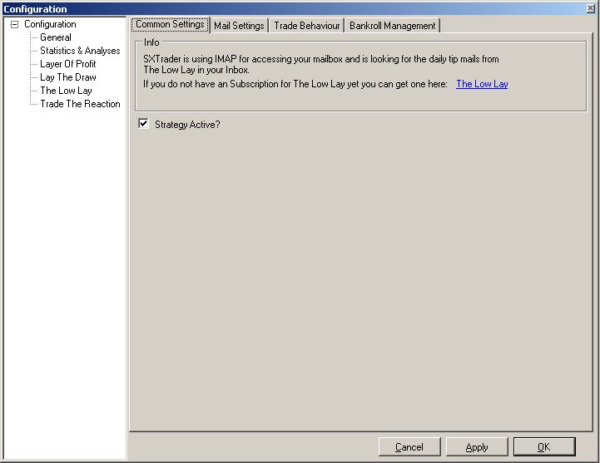

Figure 53: Configuration The Low Lay – Common Settings

At the tab “Common Settings” of the Module The Low Lay at SXTrader you have the possibility to activate or deactivate the module.

**If you change the value “Strategy Active” you have to restart SXTrader**

**The Module The Low Lay is deactivated by default after installation.**

#### Mail Settings

As SXTrader needs to read the tip emails it is necessary that it has access to the email account where the tip mails are send to.

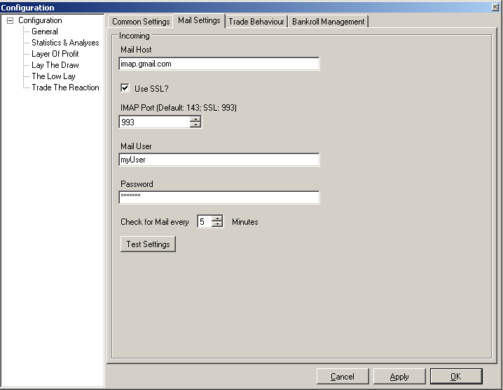

Figure 54: Configuration The Low Lay – Mail Settings

##### Mail Host

This is the URL where the IMAP-Server of the mail provide is accessable.

##### Use SSL

If the access to the mail provide is done with SSL (Secure Socket Layer) this flag must be checked.

**SXTrader is saving your account and access data encrypted.**

##### IMAP Port

The port via with the requests are send to the Mail Host. For unsecure access it is port 143 by default and for secure access via SSL it is 993 by default.

##### Mail User

The username used to log into the mail account.

##### Password

The password used to access the mail account.

##### Check for Mail every <x> Minutes

This defines the interval for SXTrader to look into the mail account for new tip mails. The range of the interval can be between 5 (Default) and 1440 Minutes.

##### Test Settings

**Testing of the settings may take several minutes of time depending on your mail provider**

By pressing this button a connection test with the current mail settings will be done.

#### Trade Behaviour

With the Trade Behaviour Settings you can control when, how and if an incoming tip mail will be processed into a bet.



Figure 55: Configuration The Low Lay – Trade Behaviour Settings

##### Maximum acceptable Lay Odd

This value defines the maximum Odd which SXTrader will use if it can not read the maximum odd given in the tip mail.

##### Begin Trade <x> Minutes before the race starts

The value defines the point of time when SXTrader should begin to try to place a bet for the tip according to the defined rules.

**Example:** The Value for begin trade is set to 60 Minutes. The daily tip of The Low Lay is telling you to lay the horse Stresa at the race Kempton at 8:30 PM. This means the earliest point in time when SXTrader is trying to place a lay bet will be 7:30 PM.

##### Keep Bet In Running

If this flag is activated the bets will be placed with the option Keep InRunning/InPlay which will cause that the bet if it isn’t matched won’t be canceled when the race starts.

##### If Lay Odds greater than max. odds

If this flag is activated SXTrader will place a lay bet for the maximum odd if the best odds for laying is greater than the defined maximum odd.

**Example:** The best lay odd for a tipp is 3.5 at the moment but the maximum allowed odd for todays tip would be 2.8. So SXTrader wouldn’t be allowed to place a lay bet for the best lay odd. Instead SXTrader is placing a bet with the odd of 2.8. Most likely this bet remains unmatched but we hope that the odds are shifting in our favor and we would be on the top of the list if the bet gets matched.

##### Non Runner Observation

If this flag is activated SXTrader will count the number of non starter at a race and deceide depending on the original start field size whether it is allowed to place a bet.

###### 1 – 5 Starter

Maximum allowed number of non starter if the starter field size is between 1 and 5 horses.

###### 6 – 10 Starter

Maximum allowed number of non starter if the starter field size is between 6 and 10 horses.

###### 11 – 15 Starter

Maximum allowed number of non starter if the starter field size is between 11 and 15 horses.

###### 16 – 20 Starter

Maximum allowed number of non starter if the starter field size is between 16 and 20 horses.

###### More than 20 Starter

Maximum allowed number of non starter if the starter field size has more than 20 horses.

##### Dynamic Betting

If this flag is activated SXTrader will not just look at the lay site of the odds but also at the back site. If it detectects a gap between the best odd at the lay side and the best odd at the back side which is greater than the defined value it will adjust its trading behaviour accordenly. The same when SXTrader detects that we have the highest odd on the back side with our unmatched bet, we are the sole bettor for that odd and there’s a gap between our odd and the seconde best back odd.

**Example 1:** The odds situation of a horse to tip is following: The best odd at the lay side is 3.1 and the best odd at the beack side is 2.2. Now SXTrader will place a lay bet for the odd of 2.21 (2.2 + 1 Tick). The bet remains unmatched. SXTrader will check the unmatched bet minutely. When checking SXTrader detects there is now a higher odd of 2.25 on the back side in front of us. Now SXTrader will cancel the bet of 2.21 and place a new on for the odd of 2.26 (2.5 + 1 Tick). SXTrade will continue this until the bet is matched or the maximum odd is reached.

**Example 2:** The odds situation of a horse to tip is following: On the back side the best odd is 2.8 and we are sole provider of that odd. The second best odd is 2.6. Now SXTrader will cancel our bet and place a new one for the odd of 2.61 (2.6 + 1 Tick).

##### If Time until Race Starts is lower than <x> Minutes

If this flag is activated and the time until race start is lower than the given amount of minutes SXTrader will stop any kind of dynamic trading, cancel all open bets and place a new lay bet for the best available lay odd or if this odd is higher than the maximum odd a lay bet for the maximum odd.

#### Bankroll Management

At the Bankroll management you are configuring the betting amount for the tips to place

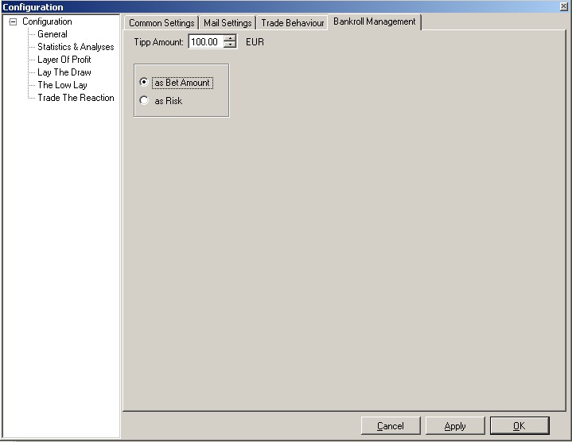

Figure 56: Configuration The Low Lay – Bankroll Management

##### Tip Amount

The amount of money to use for the bets. The value will always be in your account currency. By default SXTrader will use the minimum stake of the logged in sport exchange after installation (Betfair 2€; Betdaq 0.50€).

##### As Bet Amount

The Value of Tip Amount should be used as stake of the lay bet.

##### As Risk

The value of Tip Amount should be the maximum risk of the lay bet.

### Trade View

If a tip is detected by SXTrader its state will be displayed at the Trade View of the Module Layer Of Profit.

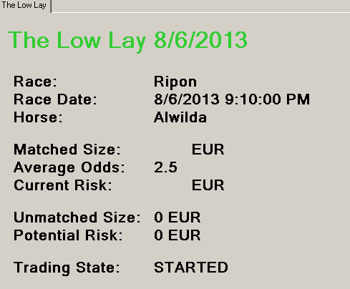

Figure 57: Trade View The Low Lay

* Race: The Race of the tip
* Race Date: The Start Time of the Race

**ATTENTION: The Race Date will always be displayed in your local time zone and not in UK-Timezone (unless you are in the UK)**

* Horse: Name of the Horse to lay
* Matched Size: The amount of money currently matched by bets. It will always be displayed in your account currency.
* Average Odds: The average Odd of all matched bets
* Current Risk: The money you are risking to loose if the lay bet is lost. It will always be displayed in your account currency.
* Unmatched Size: The amount of money placed in currently unmatched bets. It will always be displayed in your account currency.
* Potential Risk: The amount of money you are going to risk if the currently unmatched bets will be matched and you are loosing the lay bet. It will always be displayed in your account currency.
* Trading State: The state of the trade. Possible values are: STARTED;TRADING;COMPLETED;NONRUNNER und NOTTRADING

# Trade The Reaction

Coming soon.